**EXPN02 PROPERTY BUYING**

**AIM:** Create a simple cloud software application for Property Buying System using any Cloud Service Provider to demonstrate SaaS.

**Material:**

● ZOHO software.

● Data.

**Procedure:**

**Step 1**

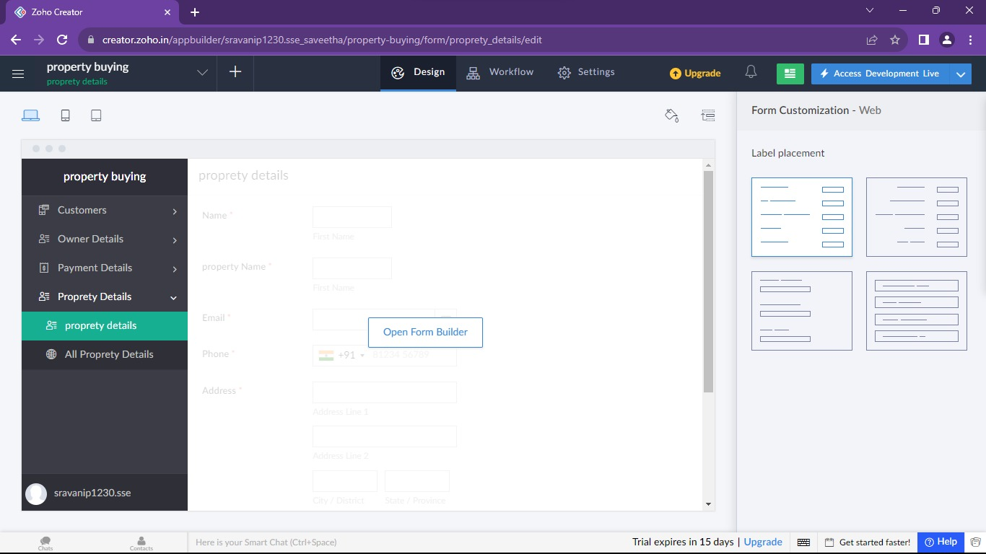

**Step 2:**

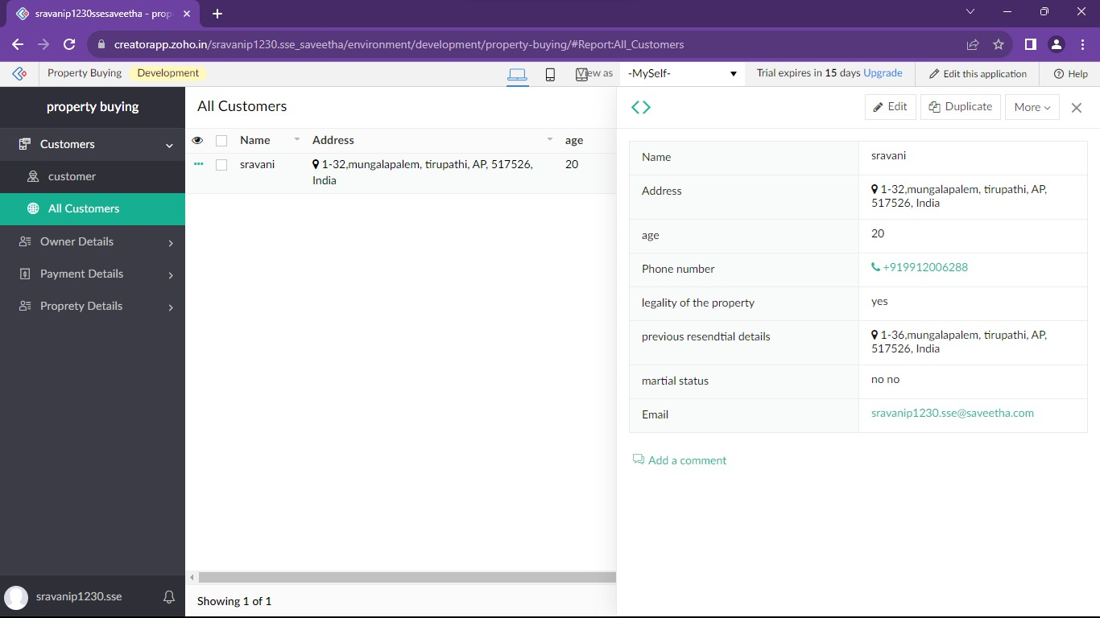

**Step 3:**

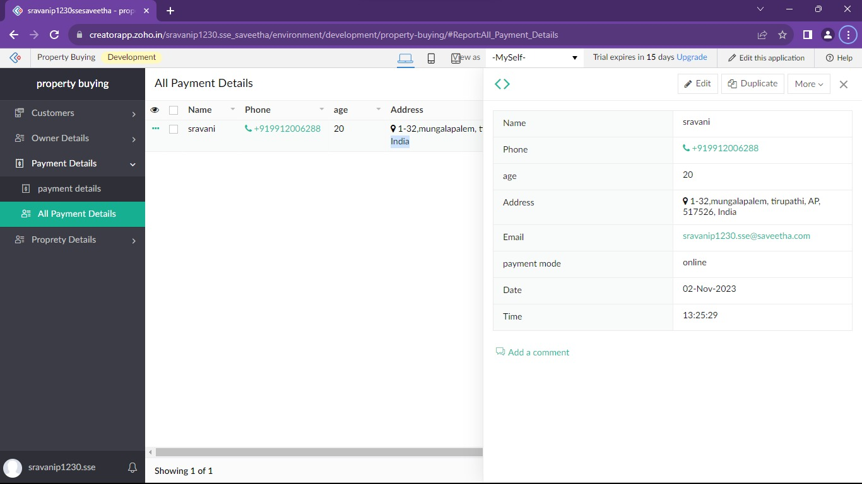

Step 4:

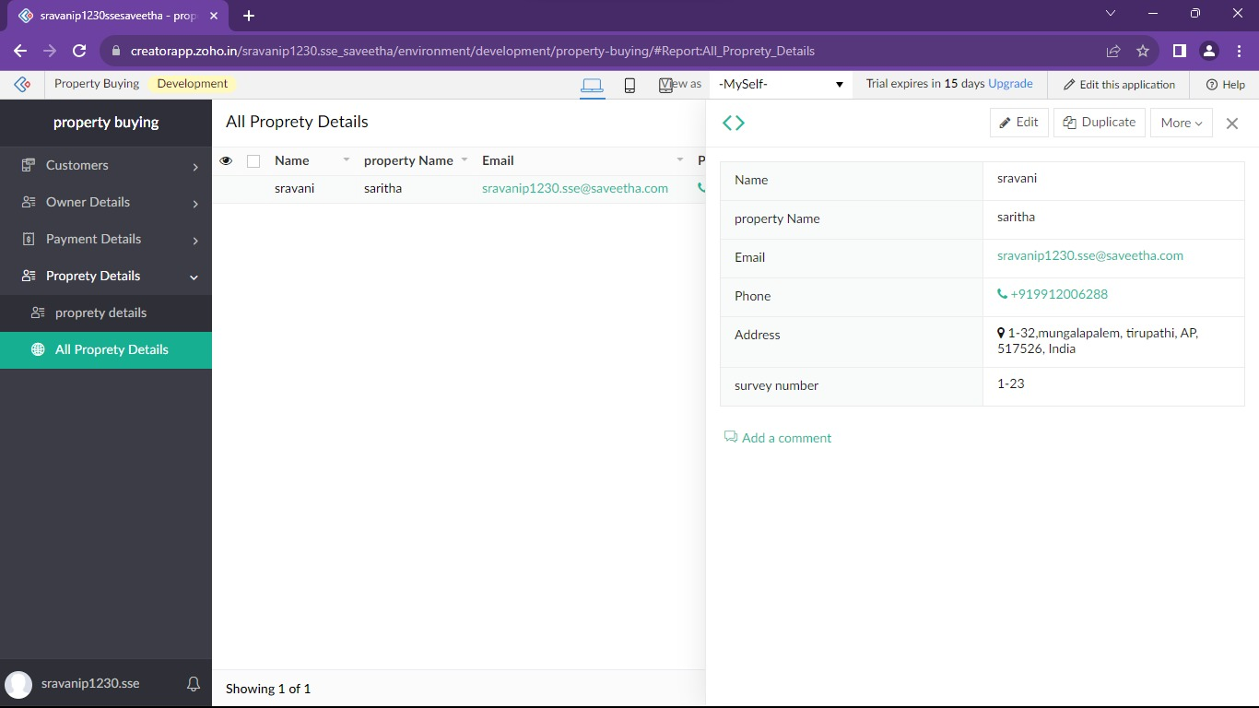

**Result:**

Successfully Developing a property buying system with Zoho ensures scalable, secure, and integrated solutions for seamless user experiences**.**